Midterm Report

2-3 Box Office Information
4-16 Studio Profiles
17-18 ‘Big Five’ Talent Agency Profiles
19 Variety Article Response
20-21 Variety Article

Christopher Meyer (801-18-5778)
RTVF 429 – Raquel Cecilia
October 15th, 2008
Box Office Information (United States: October 10th – 12th, 2008)
 |  | Title | Studio | Weekend Gross | Total Gross
 | 1 | Beverly Hills Chihuahua | Buena Vista  (Walt Disney) | $17,502,077 | $52,532,310
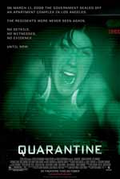 | 2 | Quarantine | Screen Gems  (Sony) | $14,211,321 | $14,211,321
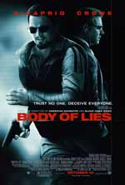 | 3 | Body of Lies | Warner Bros. | $12,884,416 | $12,884,416
 | 4 | Eagle Eye | Dreamworks  (Paramount) | $10,913,762 | $70,409,979
 | 5 | Nick and Norah's Infinite Playlist | Sony | $6,420,474 | $20,730,708
 | 6 | The Express | Universal | $4,562,675 | $4,562,675
 | 7 | Nights in Rodanthe | Warner Bros. | $4,541,201 | $32,297,101
 | 8 | Appaloosa | New Line Cinema  (Warner Bros.) | $3,321,389 | $10,867,693
 | 9 | The Duchess | Paramount Vantage  (Paramount) | $3,304,841 | $5,603,061
 | 10 | Fireproof | Samuel Goldwyn | $3,140,997 | $16,875,765
© 1998-2008 Box Office Mojo, LLC.
Box Office Information (All Time)
 |  | Title | Studio | Worldwide Gross | US Gross
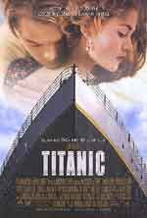 | 1 | Titanic | Paramount | $1,842,900,000 | $600,800,000
 | 2 | The Lord of the Rings: The Return of the King | New Line Cinema | $1,119,100,000 | $377,000,000
 | 3 | Pirates of the Caribbean: Dead Man’s Chest | Buena Vista | $1,066,200,000 | $423,300,000
 | 4 | The Dark Knight | Warner Bros. | $990,300,000 | $526,800,000
 | 5 | Harry Potter and the Sorcerer’s Stone | Warner Bros. | $976,500,000 | $317,600,000
 | 6 | Pirates of the Caribbean: At World’s End | Buena Vista | $961,000,000 | $309,400,000
 | 7 | Harry Potter and the Order of the Phoenix | Warner Bros. | $938,500,000 | $292,000,000
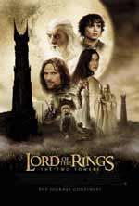 | 8 | The Lord of the Rings: The Two Towers | New Line Cinema | $925,300,000 | $341,800,000
 | 9 | Star Wars: Episode I – The Phantom Menace | 20th Century Fox | $924,300,000 | $431,100,000
 | 10 | Shrek 2 | DreamWorks SKG | $919,800,000 | $441,200,000
© 1998-2008 Box Office Mojo, LLC.
20th Century Fox
10201 W. Pico Blvd
Los Angeles, CA 90035
(310) 369 – 1000
www.fox.com

Overall Rank  1995 - 2008 Market Share | Market Share | Average Gross | Movies Released (2008)
5 | 10.96% | $48,294,610 | 16
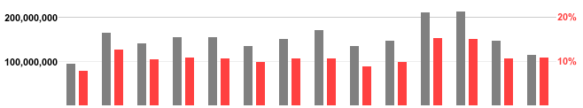
1995 1996 1997 1998 1999 2000 2001 2002 2003 2004 2005 2006 2007 2008
Market Share
Tickets Sold

Top Ten Grossing Movies of All Time
Rank | Movie Title | Total Gross | Date
1 | Star Wars: Episode I – The Phantom Menace | $431,088,301 | 5/19/99
2 | Star Wars: Episode III – Revenge of the Sith | $380,270,577 | 5/19/05
3 | Star Wars | $307,263,857 | 5/25/77
4 | Independence Day | $306,169,268 | 7/3/96
5 | Star Wars: Episode II – Attack of the Clones | $302,191,252 | 5/16/02
6 | Home Alone | $285,761,243 | 11/16/90
7 | Return of the Jedi | $252,583,617 | 5/25/83
8 | Night at the Museum | $250,863,268 | 12/22/06
9 | X-Men: The Last Stand | $234,362,462 | 5/26/06
10 | Cast Away | $233,632,142 | 12/22/00

Important People

CEO: Rupert Murdoch
Chairman: Jim Gianopoulos
Gary Newman
Tom Rothman
Dana Walden
Vice President: Peter Kang
Senior Vice President Casting: Christian Kaplan
E.V.P. of Studio Operations: J.R. DeLang
Chairman of Fox Affiliates: Joe Denk
S.V.P. Feature Film Promotions: Rita Drucker
Vice President Production: John Fox
Executive V.P. Fox Filmed Ent.: Greg Gelfan
S.V.P. of Production: Fred Baron
E.V.P. of Marketing: Daryl Cobbin
President Physical Production: Joe Hartwick
E.V.P. Finance: Dean Hallett
E.V.P. Feature Talent: Donna Isaacson
Buena Vista Pictures Distribution (Walt Disney Company)
500 S. Buena Vista St.
Burbank, CA 91521
(818) 560 – 1000
www.disney.com

Overall Rank  1995 - 2008 Market Share | Market Share | Average Gross | Movies Released (2008)
1 | 14.65% | $49,458,196 | 8
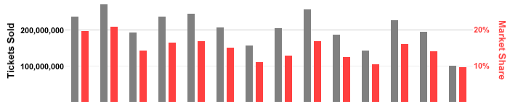
Market Share
Tickets Sold
1995 1996 1997 1998 1999 2000 2001 2002 2003 2004 2005 2006 2007 2008

Top Ten Grossing Movies of All Time
Rank | Movie Title | Total Gross | Date
1 | Pirates of the Caribbean: Dead Man's Chest | $423,315,812 | 7/7/06
2 | Finding Nemo | $339,714,978 | 5/30/03
3 | The Lion King | $312,855,561 | 6/15/94
4 | Pirates of the Caribbean: At World's End | $309,420,425 | 5/25/07
5 | Pirates of the Caribbean: The Curse of the Black Pearl | $305,413,918 | 7/9/03
6 | The Sixth Sense | $293,506,292 | 8/6/99
7 | The Chronicles of Narnia: The Lion, the Witch and the Wardrobe | $291,710,957 | 12/9/05
8 | The Incredibles | $261,441,092 | 11/5/04
9 | Monsters, Inc. | $255,873,250 | 11/2/01
10 | Toy Story 2 | $245,852,179 | 11/19/99

Important People

President (Walt Disney Studios): Alan Bergman
Chairman (Walt Disney Studios): Dick Cook
President (Buena Vista Pictures): Oren Aviv
Executive Vice President: Kristin Burr
President of Distribution: Chuck Viane
Vice President of Casting: Gail Goldberg
Executive V.P. of Casting: Marcia Ross
S.V.P. of Domestic Sales & Dist.: Jeanne Hobson
Chief Creative Officer: John Lassester

DreamWorks SKG
100 Universal City Plaza, Bldg. 10
Universal City, CA 91608
(818) 733 – 7000
www.dreamworks.com
1995 - 2008 Market Share
Overall Rank | Market Share | Average Gross | Movies Released (2008)
8 | 3.89% | $68,793,124 | 12

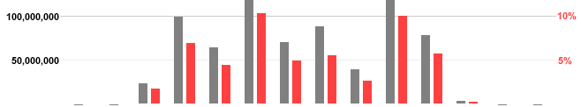
1995 1996 1997 1998 1999 2000 2001 2002 2003 2004 2005 2006 2007 2008
Market Share
Tickets Sold

Top Ten Grossing Movies of All Time
Rank | Movie Title | Total Gross | Date
1 | Shrek 2 | $436,721,703 | 5/19/2004
2 | Shrek | $267,655,011 | 5/18/2001
3 | Saving Private Ryan | $216,335,085 | 7/24/1998
4 | Gladiator | $187,683,805 | 5/5/2000
5 | Madagascar | $193,595,521 | 5/27/2005
6 | What Lies Beneath | $155,464,351 | 7/21/2000
7 | Catch Me if You Can | $164,606,800 | 12/25/2002
8 | Shark Tale | $161,192,000 | 10/1/2004
9 | American Beauty | $130,058,047 | 9/15/1999
10 | The Ring | $129,094,024 | 10/18/2002

Important People

CEO: Jeffrey Katzenburg
Stacey Snider
President of Production: Adam Goodman
Post Production Supervisor: Jake Rice
Principal: David Geffen
Steven Spielberg
Head of Publicity: Chip Sullivan
Head of Business Affairs: Chris Floyd
Focus Features
100 Universal City Plaza
Universal City, CA 91608
(818) 777 – 1000
www.focusfeatures.com

Overall Rank  1995 - 2008 Market Share | Market Share | Average Gross | Movies Released (2008)
14 | .60% | $13,925,165 | 4
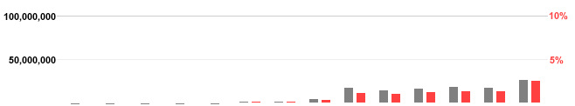
1995 1996 1997 1998 1999 2000 2001 2002 2003 2004 2005 2006 2007 2008
Market Share
Tickets Sold

Top Ten Grossing Movies of All Time
Rank | Movie Title | Total Gross | Date
1 | Brokeback Mountain | $83,043,761 | 12/9/2005
2 | The Strangers | $52,597,610 | 5/30/2008
3 | Burn After Reading | $51,678,103 | 9/12/2008
4 | Atonement | $50,980,159 | 12/7/2007
5 | Lost in Translation | $44,585,453 | 9/12/2003
6 | Pride and Prejudice | $38,372,662 | 11/11/2005
7 | Eternal Sunshine of the Spotless Mind | $34,366,518 | 3/19/2004
8 | The Pianist | $32,519,322 | 12/27/2002
9 | The Constant Gardener | $33,579,798 | 8/31/2005
10 | Balls of Fury | $32,886,940 | 8/29/2007

Important People

CEO: James Schamus
President: Andrew Karpen
Senior Vice President: Peter Kujawski
President Worldwide Publicity: Adrienne Bowles
Vice President Publicity: V.J. Carbone
Harlan Gulko
Director Physical Production: Betsy Custer
S.V.P. Physical Production: Jane Evans
President Theatrical Distribution: Jack Foley
V.P. Development & Production: David Gerson

Fox Searchlight Pictures
10201 W. Pico Blvd, Bldg. 38
Los Angeles, CA 90035
(310) 369 – 4402
www.foxsearchlight.com

Overall Rank  1995 - 2008 Market Share | Market Share | Average Gross | Movies Released (2008)
12 | .96% | $11,376,616 | 3
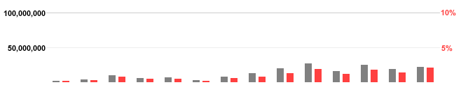
1995 1996 1997 1998 1999 2000 2001 2002 2003 2004 2005 2006 2007 2008
Market Share
Tickets Sold

Top Ten Grossing Movies of All Time
Rank | Movie Title | Total Gross | Date
1 | Juno | $143,495,265 | 12/5/07
2 | Sideways | $71,503,593 | 10/22/04
3 | Little Miss Sunshine | $59,891,098 | 7/26/06
4 | The Full Monty | $45,950,122 | 8/15/97
5 | 28 Days Later | $45,064,915 | 6/27/03
6 | Napoleon Dynamite | $44,540,956 | 6/11/04
7 | The Hills Have Eyes | $41,778,863 | 3/10/06
8 | The Ringer | $35,428,675 | 12/23/05
9 | Bend It Like Beckham | $32,543,449 | 3/12/03
10 | One Hour Photo | $31,597,131 | 8/21/02

Important People

President: Peter Rice
President Production: Stephen Gilula
Claudia Lewis
Vice President Production: Zola Mashariki
Sr. Vice President Production: Jeremy Steckler
Vice President Post Production: Nikki Scalise
Distribution: Jonathan Ross

Lionsgate Films
2700 Colorado Ave.
Santa Monica, CA 90404
(310) 449 – 9200
www.lionsgate.com

Overall Rank  1995 - 2008 Market Share | Market Share | Average Gross | Movies Released (2008)
11 | 1.49% | $11,285,471 | 13
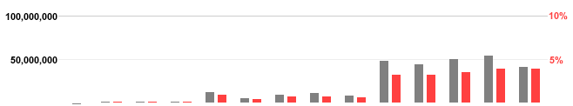
1995 1996 1997 1998 1999 2000 2001 2002 2003 2004 2005 2006 2007 2008
Market Share
Tickets Sold

Top Ten Grossing Movies of All Time
Rank | Movie Title | Total Gross | Date
1 | Fahrenheit 9/11 | $119,194,771 | 6/23/04
2 | Saw II | $87,039,965 | 10/28/05
3 | Saw III | $80,238,724 | 10/27/06
4 | Saw IV | $63,300,095 | 10/26/07
5 | Tyler Perry’s Madea’s Family Reunion | $63,257,940 | 2/24/06
6 | Tyler Perry’s Why Did I Get Married | $55,204,525 | 10/12/07
7 | Saw | $55,185,045 | 10/29/04
8 | Crash | $54,580,300 | 5/6/05
9 | 3:10 to Yuma | $53,606,916 | 9/7/07
10 | The Forbidden Kingdom | $52,075,270 | 4/18/08

Important People

CEO: Jon Feltheimer
President: Steve Beeks
Vice Chairman: Michael Burns
E.V.P. Motion Picture Production: Lisa Ellzey
S.V.P. Motion Picture Production: John Sacchi
Chief Financial Officer: Jim Keegan
President Digital Media: Curt Marvis
President Theatrical Films: Tom Ortenberg
Pres. Domestic Distribution: Steve Rothenberg
Vice President Production: Jim Miller

Metro-Goldwyn-Mayer (MGM)
10250 Constellation Blvd.
Los Angeles, CA 90067
(310) 449 - 3000
www.mgm.com

Overall Rank  1995 - 2008 Market Share | Market Share | Average Gross | Movies Released (2008)
10 | 3.28% | $17,913,023 | 9

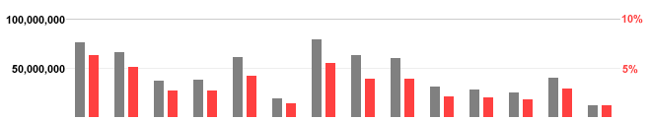
1995 1996 1997 1998 1999 2000 2001 2002 2003 2004 2005 2006 2007 2008
Market Share
Tickets Sold

Top Ten Grossing Movies of All Time
Rank | Movie Title | Total Gross | Date
1 | Gone with the Wind | $189,523,031 | 12/15/39
2 | Rain Man | $172,825,435 | 12/16/1988
3 | Hannibal | $165,092,268 | 7/21/2000
4 | Die Another Day | $160,942,139 | 11/2/02
5 | Rocky IV | $127,873,716 | 11/27/1985
6 | The World Is Not Enough | $126,943,684 | 11/19/99
7 | Tomorrow Never Dies | $125,304,276 | 12/19/97
8 | Rocky III | $125,049,125 | 5/28/1982
9 | The Birdcage | $124,060,553 | 3/8/96
10 | Rocky | $117,235,147 | 11/21/76

Important People

Chairman & CEO: Harry Evans Sloan
Executive Vice President: Scott Packman
Vice President Production: Rebecca Sloviter
Exec. Vice President Production: Cale Boyter
Sr. Vice President Media Operat.: Amy Gruberg
Chair Worldwide Motion Pictures: Mary Parent
President Distribution: Clark Woods
Miramax Films
8439 Sunset Blvd
West Hollywood, CA 90069
www.miramax.com

Overall Rank  1995 - 2008 Market Share | Market Share | Average Gross | Movies Released (2008)
9 | 3.59% | $13,013,161 | 9
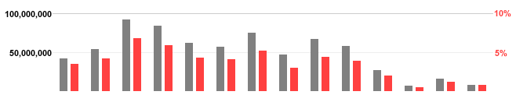
1995 1996 1997 1998 1999 2000 2001 2002 2003 2004 2005 2006 2007 2008
Market Share
Tickets Sold

Top Ten Grossing Movies of All Time
Rank | Movie Title | Total Gross | Date
1 | Chicago | $170,687,518 | 12/27/02
2 | Scary Movie | $157,019,771 | 7/7/00
3 | Good Will Hunting | $138,433,435 | 12/5/97
4 | Spy Kids | $112,719,001 | 3/30/01
5 | Pulp Fiction | $107,928,762 | 10/14/94
6 | The Aviator | $102,610,330 | 12/17/04
7 | Shakespeare in Love | $100,317,794 | 12/11/98
8 | The Others | $96,522,687 | 8/10/01
9 | Cold Mountain | $95,636,509 | 12/25/03
10 | The English Patient | $78,676,425 | 11/15/96

Important People

President: Daniel Battsek
President Production: Keri Putnam
Vice President Production: Daniel Hassid
Senior Vice President Production: Frank Rainone
Vice President Post Production: Sean Cooney
Sr. V. President Post Production: Linda Borgeson
Director Production & Develop.: Michael Falbo
V.P. Production & Development: David Greenbaum
Executive V.P. Marketing: Jason Cassidy

New Line Cinema
116 N Robertson Blvd Suite 200
Los Angeles, CA 90048
(310) 854 - 5811
www.newline.com

Overall Rank  2005 - 2008 Market Share | Market Share | Average Gross
7 | 5.94% | $39,086,459
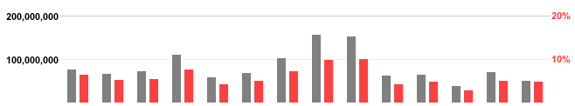
Market Share
Tickets Sold
1995 1996 1997 1998 1999 2000 2001 2002 2003 2004 2005 2006 2007 2008

Top Ten Grossing Movies of All Time
Rank | Movie Title | Total Gross | Date
1 | The Lord of the Rings: The Return of the King | $377,027,325 | 12/17/2003
2 | The Lord of the Rings: The Two Towers | $341,784,377 | 12/18/2002
3 | The Lord of the Rings: The Fellowship of the Ring | $314,776,170 | 12/19/2001
4 | Rush Hour 2 | $226,164,286 | 8/3/2001
5 | Austin Powers in Goldmember | $213,117,789 | 7/25/2002
6 | The Wedding Crashers | $209,218,368 | 7/15/2005
7 | Austin Powers: The Spy Who Shagged Me | $206,040,085 | 6/10/1999
8 | Elf | $173,398,518 | 11/7/2003
9 | Sex and the City | $173,398,518 | 5/30/2008
10 | Rush Hour | $141,186,864 | 9/18/1998

Important People

President: Toby Emmerich
President of Production: Richard Brener
Co-President Production: Erik Holmberg
Paul Prokop
Vice President Production: Keith Goldberg
Sr. Vice President Production: Walter Hamada
President of Music: Paul Broucek
President of Marketing: Chris Carlisle
Chief Financial Officer: Stephen Abramson

Paramount Pictures
55555 Melrose Ave.
Los Angeles, CA 90038
(323) 956 - 5000
www.paramount.com

Overall Rank  1995 - 2008 Market Share | Market Share | Average Gross | Movies Released (2008)
4 | 11.1% | $51,060,013 | 12
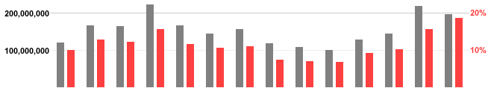
1995 1996 1997 1998 1999 2000 2001 2002 2003 2004 2005 2006 2007 2008
Market Share
Tickets Sold

Top Ten Grossing Movies of All Time
Rank | Movie Title | Total Gross | Date
1 | Titanic | $600,788,188 | 12/19/1997
2 | Forrest Gump | $329,694,499 | 7/6/1994
3 | The Transformers | $319,246,193 | 7/3/2007
4 | Iron Man | $318,313,199 | 5/2/2008
5 | Indiana Jones and the Kingdom of the Crystal Skull | $317,011,114 | 5/22/2008
6 | Raiders of the Los Ark | $245,034,358 | 6/12/1981
7 | Beverly Hills Cop | $234,760,478 | 12/5/1984
8 | The War of the Worlds | $234,280,354 | 6/29/2005
9 | Ghost | $217,631,306 | 7/13/1990
10 | Mission: Impossible 2 | $215,409,889 | 5/24/1989

Important People

Ceo: Brad Grey
Vice Chairman: Rob Moore
President Feature Productions: Mark Bakshi
Pres. Paramount Film Group: John Lesher
Pres. Paramount Studio Group: Randall Baumberger
Sr. Vice Pres. Paramount Digital: Derek Broes
Sr. Vice Pres. Production: Ben Cosgrove
Dan Levine
Exec. Vice Pres. Physical Prod.: Georgia Kacandes
Vice President Paramount Studio: Adam Kassan

Sony Pictures
10202 W. Washington Blvd.
Culver City, CA 90232
(310) 244 - 4000
www.spec.sony.com

Overall Rank  1995 - 2008 Market Share | Market Share | Average Gross | Movies Released (2008)
3 | 12.45% | $39,933,572 | 16
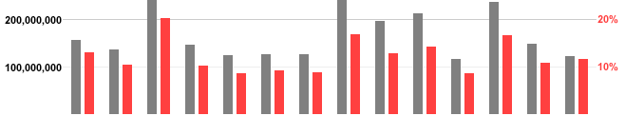
1995 1996 1997 1998 1999 2000 2001 2002 2003 2004 2005 2006 2007 2008
Market Share
Tickets Sold

Top Ten Grossing Movies of All Time
Rank | Movie Title | Total Gross | Date
1 | Spider-Man | $403,706,375 | 5/3/2002
2 | Spider-Man 2 | $373,524,485 | 6/30/2004
3 | Spider-Man 3 | $336,560,303 | 5/4/2007
4 | Men in Black | $250,690,539 | 7/2/1997
5 | Ghost Busters | $238,632,124 | 6/8/1984
6 | Hancock | $227,946,274 | 7/2/2008
7 | The Da Vinci Code | $217,536,138 | 5/19/2006
8 | Terminator 2: Judgment Day | $204,859,496 | 7/3/1991
9 | Men in Black 2 | $190,418,803 | 7/3/2002
10 | Gladiator | $187,683,805 | 5/5/2000

Important People

CEO & Chairman: Michael Lynton
Howard Stringer
Co-Chairman: Amy Pascal
Executive Vice President & CFO: David Handler
Vice President: Karen Halby
President Sony Picture Tech.: Chris Cookson
President Digital Production: Bob Osher
Exec. Vice President: Andre Caraco

Universal Pictures
100 Universal City Plaza
Universal City, CA 91608
(818) 777 – 1000
www.universalstudios.com

Overall Rank  1995 - 2008 Market Share | Market Share | Average Gross | Movies Released (2008)
6 | 10.67% | $48,927,821 | 14

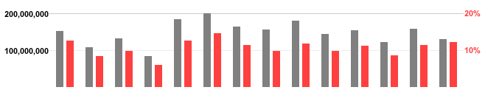
1995 1996 1997 1998 1999 2000 2001 2002 2003 2004 2005 2006 2007 2008
Market Share
Tickets Sold

Top Ten Grossing Movies of All Time
Rank | Movie Title | Total Gross | Date
1 | E.T.: The Extra-Terrestrial | $359,197,037 | 6/11/82
2 | Jurassic Park | $357,067,947 | 6/11/93
3 | Meet the Fockers | $279,261,160 | 12/22/04
4 | How the Grinch Stole Christmas | $260,044,825 | 11/17/00
5 | Jaws | $260,000,000 | 6/20/75
6 | Bruce Almighty | $242,829,261 | 5/23/03
7 | The Lost World: Jurassic Park | $229,086,679 | 5/23/97
8 | The Bourne Ultimatum | $227,471,070 | 8/3/07
9 | King Kong | $218,080,025 | 12/14/05
10 | Back to the Future | $210,609,762 | 7/3/85

Important People

General Manager: M.H. Hoffman
Co-Chairman: David Linde
Marc Shmuger
Vice Chairman: Rick Finkelstein
Senior Vice President: Hollace Davids
Executive Vice President: Michael Joe
President Production: Donna Langley
Vice President Production: Dylan Clark
Kristin Lowe
Rebecca Sloviter
Exec. Vice President Production: Peter Cramer
Tracy Falco
Sr. Vice President Production: Scott Bernstein
President Marketing: Eddie Egan

Warner Bros. Pictures
4000 Warner Blvd.
Burbank, CA 91522
(818) 954 - 6000
www.warnerbros.com

Overall Rank  1995 - 2008 Market Share | Market Share | Average Gross | Movies Released (2008)
2 | 13.45% | $44,062,770 | 15
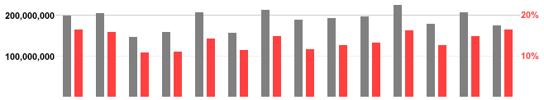
1995 1996 1997 1998 1999 2000 2001 2002 2003 2004 2005 2006 2007 2008
Market Share
Tickets Sold

Top Ten Grossing Movies of All Time
Rank | Movie Title | Total Gross | Date
1 | The Dark Knight | $526,783,113 | 7/18/08
2 | Harry Potter and the Sorcerer's Stone | $317,575,550 | 11/16/01
3 | Harry Potter and the Order of the Phoenix | $292,004,738 | 7/11/07
4 | Harry Potter and the Goblet of Fire | $290,013,036 | 11/18/05
5 | The Matrix Reloaded | $281,576,461 | 5/15/03
6 | Harry Potter and the Chamber of Secrets | $261,988,482 | 11/15/02
7 | I Am Legend | $256,393,010 | 12/14/07
8 | Batman | $251,188,924 | 6/23/89
9 | Harry Potter and the Prisoner of Azkaban | $249,541,069 | 6/4/04
10 | Twister | $241,721,524 | 5/10/96

Important People

President: Jeffrey Robinov
Senior Vice President: Frank Urioste
Vice President Production: Matt Reilly
Sarah Schchter
Exec. Vice President Production: Bill Draper
Jessica Goodman
Lynn Harris
Greg Silverman
Senior Vice President Production: Jon Berg
Ravi Mehta
Mark Scoon
Sr. V. President Post Production: Bill Daly

Creative Artists Agency (CAA)
Rick Nicita & Richard Lovett
2000 Avenue of the Stars
Los Angeles, CA 90067
(424) 288 - 2000
Arguably the most powerful talent agency in the business, Creative Artists Agency (CAA) represents clients working in film, TV, theater, music, and literature. The firm represents a gaggle of the day's top female stars such as Cameron Diaz, Nicole Kidman, Angelina Jolie, Julia Roberts, and Meryl Streep. Other heavy-hitting clients include actors Tom Cruise, Tom Hanks, and musicians Alanis Morissette and Beyoncé Knowles, as well as corporate clients such as Coca-Cola and toymaker Mattel. Supplemental services include strategic counsel, financing, and consulting. Its Intelligence Group/Youth Intelligence unit tracks and conducts behavior research for consumers from ages 8 to 39. CAA was founded in 1975.

Endeavor Talent Agency
Robert T. Brennan
9701 Wilshire Blvd., 10th Floor
Beverly Hills, CA
(310) 248-2000
The Endeavor Talent Agency is a Beverly Hills, California based talent and literary agency, representing actors, writers and directors for film, television and video games. Currently, there are around 190 staff /client members.

International Creative Management, Inc. (ICM)
Jeffrey Berg & Chris Silbermann
10250 Constellation Blvd.
Los Angeles, CA 90067
(310) 550 - 4000
The agency represents actors and directors, as well as artists in theater, music, publishing, and new media. One of the major "10 percenteries" (along with CAA and William Morris), ICM represents high-profile clients including Richard Gere, Halle Berry, and Beyonce Knowles. ICM also arranged financing for Oscar-nominated films such as "Gosford Park, Moulin Rouge," and "The Fellowship of the Ring." The agency has lost several star agents in recent years, along with big-name clients (including Cameron Diaz and Julia Roberts) to its competitors. ICM was formed in 1975 by the merger of Creative Management Associates and The International Famous Agency

United Talent Agency (UTA)
Jim Berkus & Chris Day
9560 Wilshire Blvd., Ste. 500
Beverly Hills, CA 90212-2401
(310) - 273-6700
United Talent Agency (UTA) is a Hollywood talent agency representing big-name movie celebrities such as Harrison Ford, Jack Black, Rachel McAdams, and Johnny Depp as well as a client list of directors and screenwriters, including the Coen brothers ("Fargo") and Alan Ball ("American Beauty, Six Feet Under"). UTA arranges financing for films ("Signs, Igby Goes Down") and TV shows. It has also launched UTA Online, a unit representing Internet talent. Founded in 1991 with 26 agents, UTA now has about 100. Based in Beverly Hills, the agency is owned by 20 partners through a structure designed to spread ownership among its top agents.

William Morris Agency
Norman Brokaw & James Wiatt
1 William Morris Place
Beverly Hills, CA 90212
(310) 859 - 4000
The venerable talent agency (which represented such stars as Clark Gable, Judy Garland, and Marilyn Monroe in its heyday) has added big-name recording artists such as Eminem to its roster of legendary talent. WMA also represents film actors, TV stars (Ray Romano), and athletes (Michelle Wie). A strong literary agency, WMA boasts a handful of agents, including former Random House editor Manny Baron, to increase its client list of authors. The employee-owned agency started in 1898 as William Morris, Vaudeville Agent, by its namesake -- a booking agent in New York City

It’s no surprise to see Lionsgate Films CEO Jon Feltheimer extending his tenure another three years with the company. Lionsgate is a relatively new studio on the scene, but already it has grown with tremendous leaps and bounds under Feltheimer’s leadership, and this is quite peculiar when analyzing the films that have led to Lionsgate’s successes.
What is extremely interesting when it comes to Lionsgate Films is how it has built its success around just a few decent repeat titles but somehow still manages to grow and develop with completely different genres besides its few steeples. For example, all of the Saw movies (Saw I-IV, and Saw V is currently in production) are part of Lionsgate’s top ten films of all time, and as all horror movies you would think you would see at least one more horror movie in Lionsgate’s top ten list; but no. In fact, the top ten list is lead by Fahrenheit 9/11, a mocumentary completely different from the horror genre, and the one and only documentary type film in a top ten list for a studio at all. Furthermore, movies like Crash, and the Tyler Perry series additionally prove how diverse Lionsgate films are.
Every studio has movies that are generally in the same categories in their top ten lists, but Lionsgate Films definitely does not. Perhaps this is due to Jon Feltheimer’s success as CEO, and with an extra three years in office and an economy that is screaming for help it will be interesting to see how the next few years will play out for Lionsgate.
Posted: Tue., Oct. 14, 2008, 11:22am PT

Feltheimer extends stay at Lionsgate

CEO signs long-term agreement with studio

By DAVE MCNARY
With Lionsgate in expansion mode, topper Jon Feltheimer has signed a long-term agreement with the mini-major, extending his tenure as co-chairman and CEO until March 2014.
Feltheimer’s previous contract ran through March 2011. Lionsgate also announced Tuesday that Michael Burns had extended his contract as vice chairman until September 2011.
Feltheimer, who joined Lionsgate eight years ago, told Daily Variety that the moves underlined the board’s confidence in the company’s current strategies of growth and diversification to establish increased traction in features, TV, syndication and new media.
"We’ve been sticking very much to our long-term business principles and expecting to weather the current economic problems," he said. On Tuesday, Lionsgate shares declined 16¢ to close at $6.65. Shares hit a 52-week low of $5.59 last week.
Feltheimer noted that during his tenure, annual revenues have jumped from $100 million to $1.4 billion. In addition, Lionsgate is debt free, with about $250 million in cash and a $340 million credit line that hasn’t been tapped.
He added that the length of the pact is typical of those for studio chiefs and noted that the first discussion of the extensions began several weeks ago.
Under the new deal, Feltheimer’s base salary of $1.2 million remains the same until 2011, when it rises in accordance with the consumer price index. The pact also provides that he’ll receive 458,036 shares of stock vesting over a three-year period starting in 2012, giving him a 1.5% ownership stake.
The new pacts for Feltheimer and Burns come as Lionsgate has been ramping up operations and revamping its senior management for the past year, starting with the purchase of Mandate Pictures.
Former Paramount exec Alli Shearmur joined the company in late summer as president of motion picture production and as head of a new production wing. Lionsgate’s goal is to become a more broad-based shop with an emphasis on mainstream pics beyond its signature "Saw" and Tyler Perry franchises and other genre fare.
Lionsgate has been notably active on the releasing front in recent weeks, with Tyler Perry’s "The Family That Preys" and Bill Maher’s docu "Religulous." It opens Oliver Stone’s "W." this weekend and "Saw V" at the end of the month, followed by "Transporter 3," "Punisher: War Zone" and "The Spirit."
In addition to boosting film operations, Lionsgate has also been expanding in new media with a partnership in the FearNet cable channel with Sony and Comcast. It also cut a ground-breaking deal with YouTube to make excerpts from several hundred of its film and TV productions available on a branded YouTube channel.
Lionsgate's received accolades for producing "Mad Men" for AMC. It also produces "Weeds" and "Tyler Perry's House of Payne."
Read the full article at:
http://www.variety.com/article/VR1117993963.html
© 2008 Reed Business Information

